CANCER RISK PREDICTOR
A MINI-PROJECT REPORT
Submitted by
ABHINAYA RD 241801004
ANDRYAN DURAI 241801020

in partial fulfillment of the award of the degree
of
BACHELOR OF ENGINEERING
IN
ARTIFICIAL INTELLIGENCE AND DATA SCIENCE

RAJALAKSHMI ENGINEERING COLLEGE, CHENNAI
An Autonomous Institute
CHENNAI
OCTOBER 2025

BONAFIDE CERTIFICATE
Certified that this project “CANCER RISK PREDICTOR” is the bonafide work of “ABHINAYA RD AND ANDRYAN DURAI” who carried out the project work under my supervision.

SIGNATURE
Dr. R.SAVITHRI,
ASSISTANT PROFESSOR SG
Department of Artificial Intelligence and Data Science,
Rajalakshmi Engineering College,
Chennai

This mini project report is submitted for the viva voce examination to be held on __________

INTERNAL EXAMINER EXTERNAL EXAMINER
ABSTRACT

The Cancer Risk Predictor project aims to develop an intelligent system capable of assessing an individual’s likelihood of developing specific types of cancer based on key health indicators and lifestyle factors. This system focuses on four major cancers such as lung, breast, skin, and kidney which are among the most prevalent and life-threatening forms worldwide. By utilizing machine learning algorithms and analysing datasets containing patient health records, the model identifies patterns and correlations between symptoms, medical history, and risk levels. The proposed system allows users to input general health data such as age, gender, genetic history, smoking habits, body mass index (BMI), and other relevant parameters. The trained predictive model then estimates the probability of cancer occurrence and provides personalized insights for preventive measures. This approach not only assists individuals in understanding their health risks but also supports healthcare professionals in early diagnosis and intervention planning.
Overall, the Cancer Risk Predictor project demonstrates how artificial intelligence and data analytics can be effectively integrated into healthcare to enhance early detection, risk assessment, and awareness, ultimately contributing to the reduction of cancer mortality through timely action and prevention.

ACKNOWLEDGEMENT

We express our sincere thanks to our beloved and honorable chairman MR. S. MEGANATHAN and the chairperson DR. M.THANGAM MEGANATHAN for their timely support and encouragement.
We are greatly indebted to our respected and honorable principal
Dr. S.N. MURUGESAN for his able support and guidance.
No words of gratitude will suffice for the unquestioning support extended to us by our Head Of The Department Dr. J.M.GNANASEKAR and our Deputy Head Of The Department Dr. J. MANORANJINI for being ever supporting force during our project work
We also extend our sincere and hearty thanks to our internal guide Dr. R.SAVITHRI , for her valuable guidance and motivation during the completion of this project.
Our sincere thanks to our family members, friends and other staff members of Artificial Intelligence and Data Science.
1. ABHINAYA RD
2. ANDRYAN DURAI

TABLE OF CONTENTS

CHAPTER NO. TITLE PAGE NO
ABSTRACT iv

1 INTRODUCTION 1
1.1 INTRODUCTION 8
1.2 SCOPE OF THE WORK 8
1.3 PROBLEM STATEMENT 8
1.4 AIM AND OBJECTIVES OF THE PROJECT 9
2 SYSTEM SPECIFICATIONS
2.1 SOFTWARE SPECIFICATIONS 10
3 MODULE DESCRIPTION 11
4 CODING 12

5 SCREENSHOTS 16
6 CONCLUSION AND FUTURE ENHANCEMENT 20
REFERENCES 21

LIST of figures
FIGURE NO. | TITLE | PAGE NO.
5.1 | REGISTER PAGE | 16
5.2 | LOGIN PAGE | 16
5.3 | USER DETAILS | 17
5.4 | RISK PREDICTOR | 18
5.5 | DATABASE CREATION | 19

CHAPTER 1
INTRODUCTION
  - INTRODUCTION
The Cancer Risk Predictor is a machine learning-based system designed to estimate an individual’s likelihood of developing cancer using health and lifestyle data. It focuses on four major types like lung, breast, skin, and kidney cancer. By analysing factors like age, gender, family history, BMI, and habits such as smoking, the model predicts potential cancer risk levels. The project aims to create awareness, promote early detection, and assist in preventive healthcare by providing users with a simple and accessible risk assessment tool.
  - SCOPE OF THE WORK
The project involves collecting and preprocessing health datasets related to cancer, selecting important features that influence cancer risk, training and testing a predictive model using machine learning algorithms. A user-friendly interface is developed to allow individuals to input their health details and view the predicted results. The model’s accuracy and reliability are evaluated to ensure effective performance. This system serves as a preventive tool to help individuals understand their cancer risk and take timely medical advice

  - PROBLEM STATEMENT
Early detection of cancer significantly improves treatment outcomes, but many people delay medical consultation due to lack of awareness, stigma, or access to timely screening. There is no easily accessible, user-friendly tool that allows individuals to self-assess symptoms, understand their potential risk level, and be guided toward appropriate medical action. This gap leads to missed opportunities for preventive care and early intervention
1.4 AIM AND OBJECTIVES OF THE PROJECT
The aim of this project is to develop a machine learning-based Cancer Risk Predictor that can estimate an individual’s likelihood of developing cancer based on various health and lifestyle factors, helping to promote early detection and preventive healthcare. The main objectives include collecting and analyzing health-related data for major cancer types such as lung, breast, skin, and kidney cancer identifying key features that influence cancer risk, designing and training an accurate predictive model using suitable machine learning algorithms, developing an user friendly interface for data input, risk display and evaluating the model’s performance for accuracy and reliability. Ultimately, the project aims to raise awareness and assist individuals in taking timely preventive medical actions.

CHAPTER 2
SYSTEM SPECIFICATIONS
2.1 SOFTWARE SPECIFICATIONS
Operating System | : | WINDOWS 10
Front – End | : | HTML, CSS
Back - End | : | Python
Language | : | Python, SQL

CHAPTER 3
MODULE DESCRIPTION
This application consists of a single User Login module. When the program runs, the user is prompted to log in by entering a valid username and password. After successful login, the user can input personal health details such as age, gender, BMI, smoking habits, family history, and other lifestyle factors. Based on the provided information, the system analyses the data using a trained machine learning model and displays the predicted cancer risk level in a clear and organized tabular format. This allows users to understand their potential cancer risk and take necessary preventive or medical actions.

CHAPTER 4
SAMPLE CODING
Sample 1
Sample 1 depicts the display code, that gets the data from the database i.e. being stored there and represented on users demand with the layout and measurements i.e. being already specified.
app = Flask(_name_)
app.secret_key = 'REPLACE_WITH_A_SECURE_RANDOM_KEY'
app.config['SQLALCHEMY_DATABASE_URI'] = 'sqlite:///site.db'
db = SQLAlchemy(app)

def generate_next_health_id():
last_user = User.query.order_by(User.health_id.desc()).first()
if last_user is None:
return 10000
return last_user.health_id + 1

class User(db.Model):
id = db.Column(db.Integer, primary_key=True)
username = db.Column(db.String(80), unique=True, nullable=False)
password_hash = db.Column(db.String(128), nullable=False)
age = db.Column(db.Integer, nullable=False)
email = db.Column(db.String(120), unique=True, nullable=False)
phone = db.Column(db.String(15), nullable=False)
health_id = db.Column(db.Integer, unique=True, nullable=False)
user_symptom = db.relationship('UserSymptom', uselist=False, backref='user')
risk_results = db.relationship('RiskResult', backref='user', lazy=True)

def set_password(self, password):
self.password_hash = generate_password_hash(password)

def check_password(self, password):
return check_password_hash(self.password_hash, password)

class Symptom(db.Model):
id = db.Column(db.Integer, primary_key=True)
symptom_name = db.Column(db.String(120), unique=True, nullable=False)
category = db.Column(db.String(20))

class UserSymptom(db.Model):
id = db.Column(db.Integer, primary_key=True)
user_id = db.Column(db.Integer, db.ForeignKey('user.id'), nullable=False, unique=True)
general_symptoms = db.Column(db.String) # Lung Cancer Symptoms
breast_symptoms = db.Column(db.String) # Breast Cancer Symptoms
skin_symptoms = db.Column(db.String) # Skin Cancer Symptoms
kidney_symptoms = db.Column(db.String) # Kidney Cancer Symptoms

class RiskResult(db.Model):
id = db.Column(db.Integer, primary_key=True)
user_id = db.Column(db.Integer, db.ForeignKey('user.id'), nullable=False)
risk_percentage = db.Column(db.Float)
risk_level = db.Column(db.String(20))
recommendation = db.Column(db.String(255))
date = db.Column(db.DateTime, default=datetime.utcnow)

Sample 2
Sample 2 depicts the predicting part of the code, where it displays predicted details and enter user data and store it in database

CHAPTER 5
SCREEN SHOTS
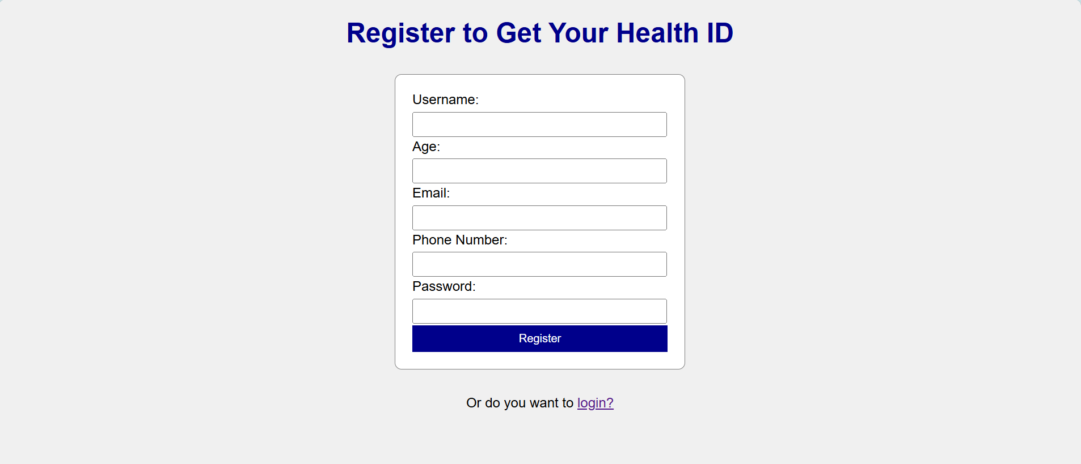
Fig 5.1 REGISTER PAGE
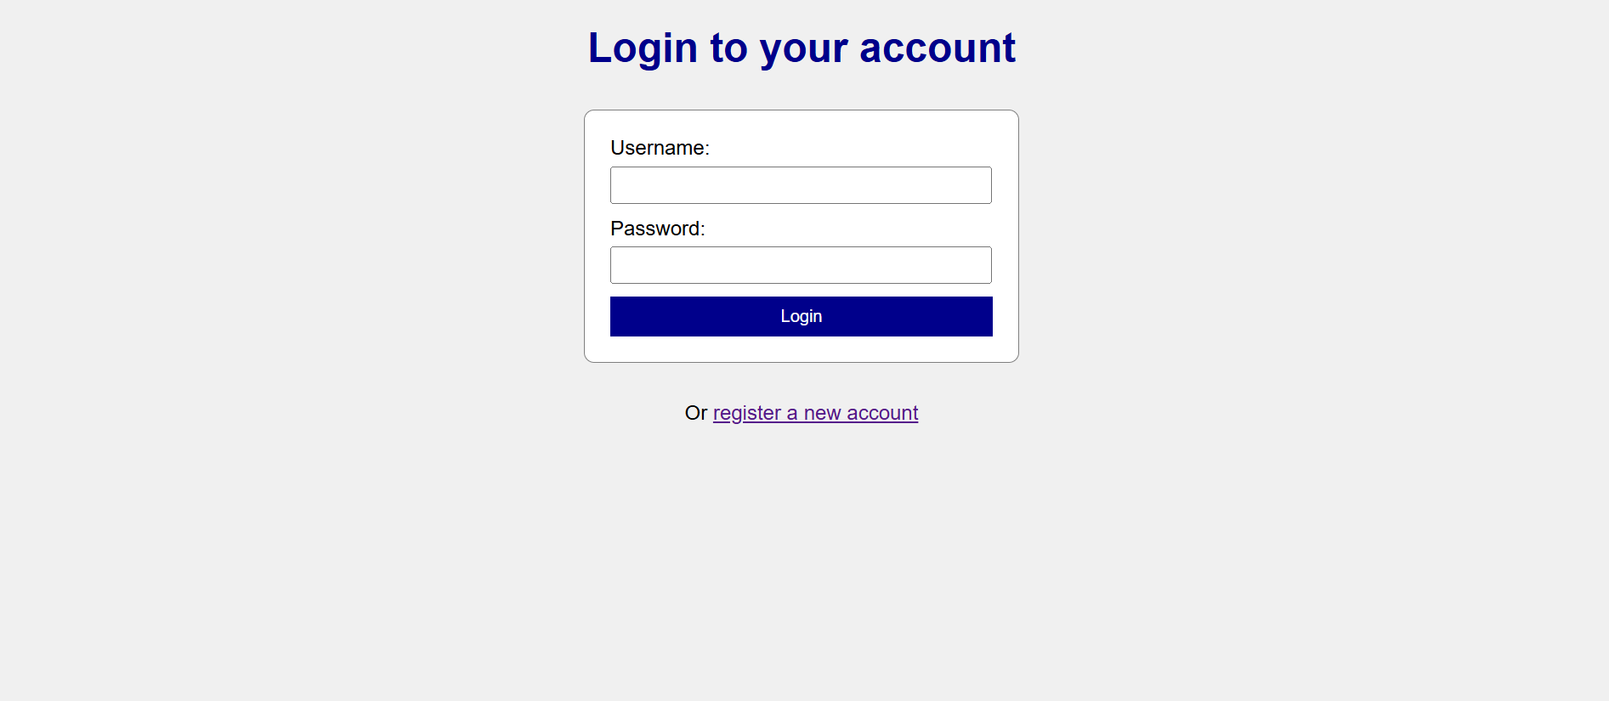
Fig 5.2 LOGIN PAGE

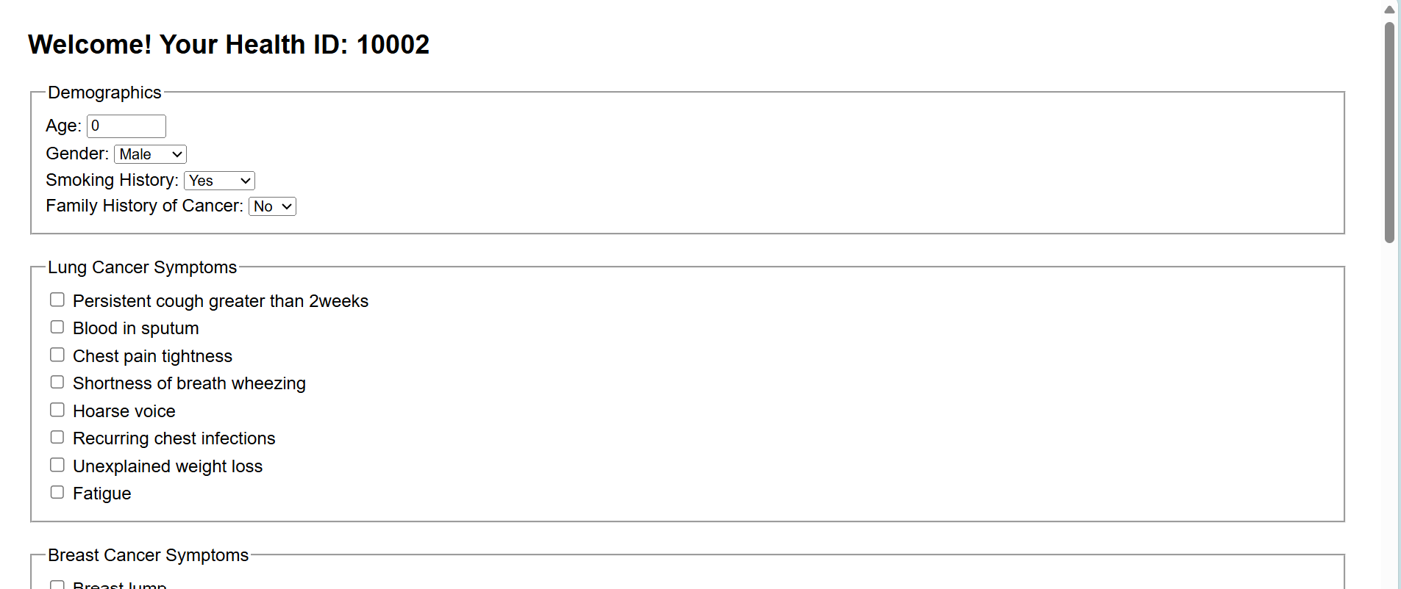

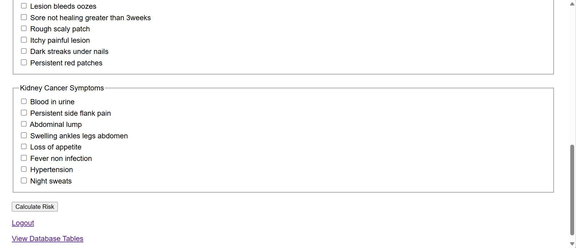

Fig 5.3 USER DETAILS

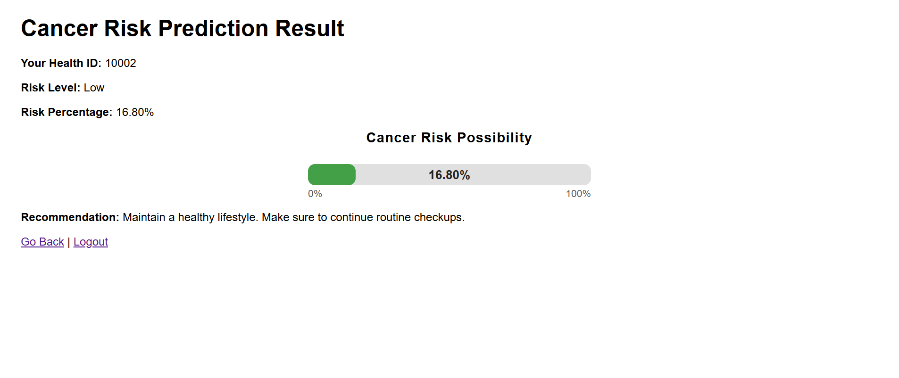
Fig 5.4 RISK PREDICTOR

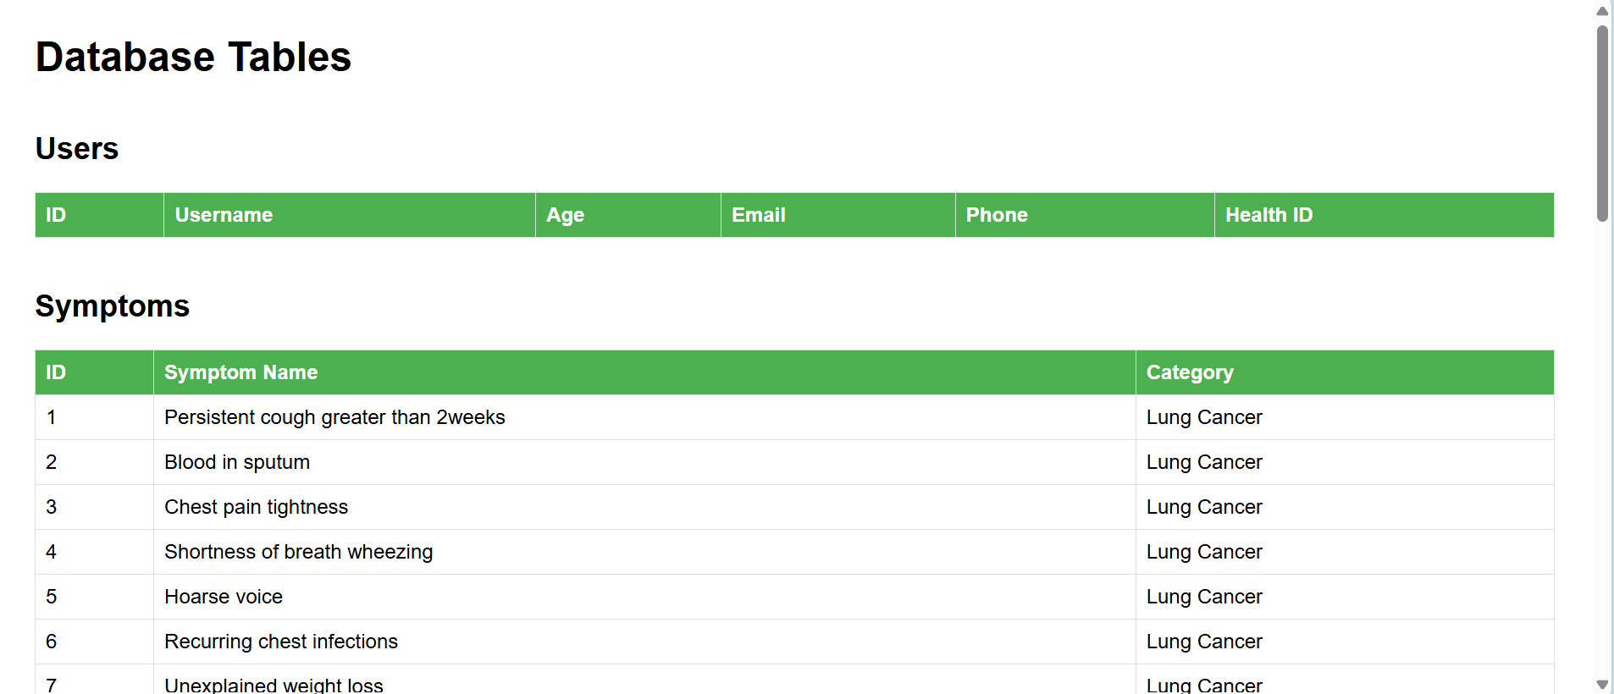
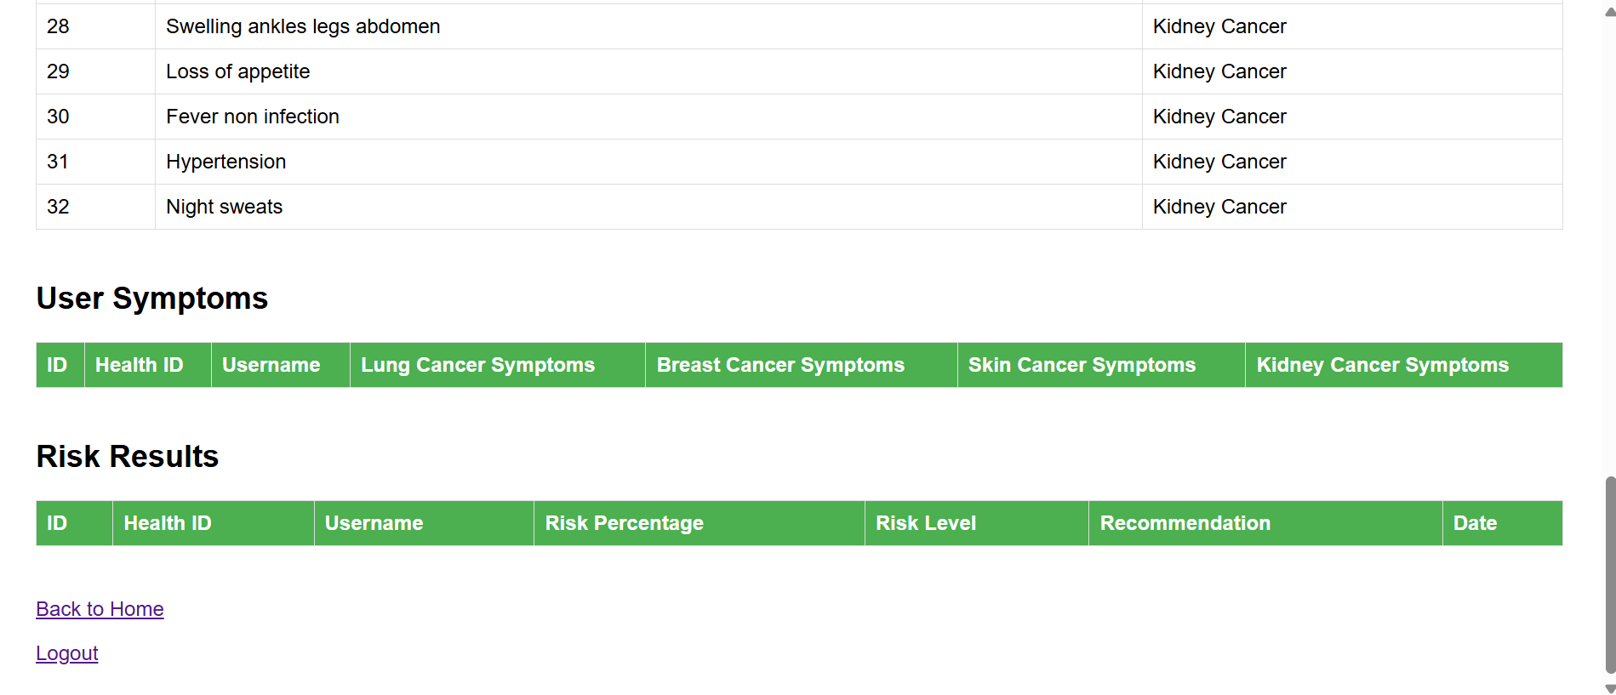Fig 5.6 DATA BASE CREATION

CHAPTER 6
CONCLUSION AND FUTURE ENHANCEMENT
The Cancer Risk Predictor project demonstrates how machine learning can be effectively used to estimate the likelihood of developing cancer based on health and lifestyle factors such as age, gender, BMI, family history, and smoking habits. It provides users with an easy-to-use platform to understand their potential cancer risk, encouraging early detection and preventive healthcare. In the future, the system can be enhanced by integrating real-time medical data from wearable devices and hospital databases, expanding to include more cancer types, and incorporating genetic and clinical parameters for greater accuracy. A web or mobile version can also be developed for wider accessibility, and advanced AI models like deep learning can be implemented to further improve prediction performance and reliability.

REFERENCES
- https://www.w3schools.com/sql/
- https://www.tutorialspoint.com/sqlite/index.htm
- https://www.wikipedia.org/
- https://www.learnpython.org/
- https://www.codecademy.com/learn/learn-python

